

IBM RPA Reporting

Hands-on Lab

*Version 1.0*

*Public*

*Authors:*

*Nigel T. Crowther – ncrowther@uk.ibm.com*

**Table of Contents**

1. Introduction 3

Prerequisites 3

2. Lab Instructions 4

# Introduction

IBM RPA Automation Studio has a built in Reporting tool. This tool allows you to create  
custom reports using multiple data sources. You can export and print   
reports and even email it in a completely automated manner, without the need for any human interaction.

For a detailed course on reporting see the following video:

<https://learn.ibm.com/course/view.php?id=8695>

## 

## Prerequisites

Nothing. Your environment is already configured, and everything is set. Ready to start.

# Lab Instructions

Open IBM RPA Studio and click *New*:

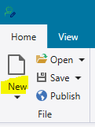

Select *Report File*:

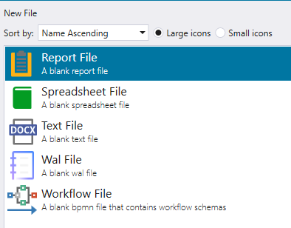

Clicking the *Open* button opens the Report Wizard. This wizard allows you to  
create reports based on predefined templates, In this lab we’ll keep things simple and create an empty report.

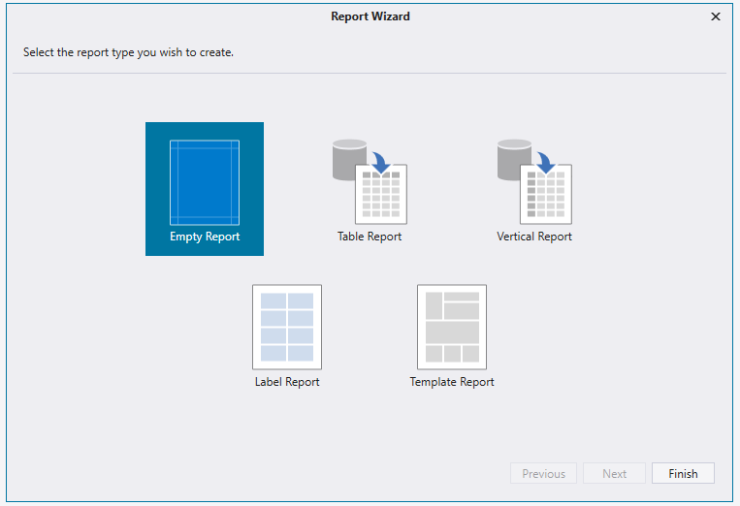

Click *Finish*

An empty report appears:

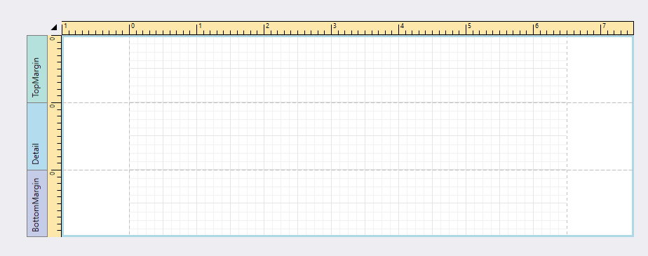

Reports are saved as an asset within a bot script. Therefore, you  
need to save the script so that you can re-access and edit the reports.  
  
Go back to the script creation tab in RPA Studio. Search the  
Toolbox commands for "report," you can see the commands:

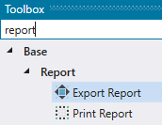

The Print Report Command allows you to print reports to a configured printer. We will not be using this command in the lab.

The Export Report Command allows you to supply parameters to the report and export it as a PDF.

